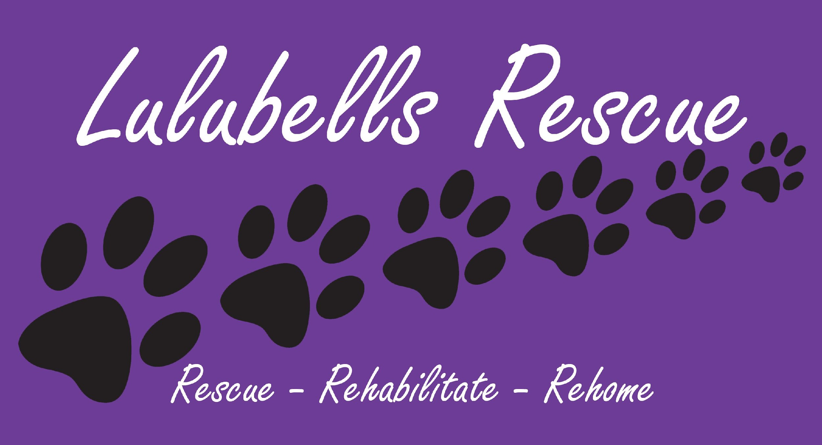

**Fostering Application Form**

| **About You** |  | | | | |  | | |  | |
| --- | --- | --- | --- | --- | --- | --- | --- | --- | --- | --- |
| Name: | | | | | | | | | D.O.B: | |
| Address: | | | | | | | | | Postcode: | |
| Home Phone No: | | | | | | | | | Mobile No: | |
| Email Address: | | | | | | | | | Occupation: | |
|  |  | | | | |  | | |  | |
| **Please state how you heard about Lulubells Rescue:** | | | | | | | | | | |
|  |  | | | | |  | | | |  |
| **About Your Home** |  | | | | |  | | | |  |
| Where do you live?  (Please Circle) | | ☐ A House  ☐ An Apartment  ☐ A Boat | | | | | | ☐ A Dormitory  ☐ Other (Please Specify) | | |
|  | |  | | | | | | | | |
| Is your home located near a | | ☐ Motorway? | | | | | ☐ Railway Line? | | | |
|  | |  | | | | | | | | |
| Do you: ☐ Rent ☐ Own  If you rent, who do you rent it from?  Do you have written permission from your landlord to have pets? ☐ Yes ☐ No  (Please attach a copy of this with the form) | | | | | | | | | | |
|  | |  | | | | | | | | |
| Do you have access to a secure garden / yard? ☐ Yes ☐ No | | | | | | | | | | |
| What type and how high are the fences / walls? | | | | | | | | | | |
| Does your garden have a gate? ☐ Yes ☐ No  (If yes, is it secured and locked?) | | | | | | | | | | |
|  | | | | | | | | | | |
| Does it have a pool or a pond? ☐ Yes ☐ No | | | | | | | | | | |
|  | | |  | | | | | | | |
| Who lives in your home?  (Please provide the ages of all children under 18) | | | | | | | | | | |
|  | | | | | | | | | | |
| How active are you? | | | | | | | | | | |
|  | | | | | | | | | | |
| Are your tetanus vaccinations up to date? ☐ Yes ☐ No  (Please advise when your last tetanus jab was?) | | | | | | | | | | |
|  | | | | | | | | | | |
| **Animals** | | | | | | | | | | |
| What type of animals would you be happy to foster?  (Please TICK each animal you are happy to foster) | | | | ☐ Cats  ☐ Dogs  ☐ Small Animals (Rabbits, Hamsters, etc.)  ☐ Birds (Parrots, Budgies, Chickens, Quails, etc.)  ☐ Reptiles (Bearded Dragons, Lizards, etc.)  ☐ Exotic Animals (Ferrets, Tortoises, etc) | | | | | | |
| Are there any animals you would not be able to foster?  (Please CROSS OUT each you would NOT be happy to foster) | | | | * Young Cats or Dogs (6 weeks or under) * Senior Cats or Dogs * Animals on medicine * Animals with long term medical conditions * Feral Animals / Animals with behaviour issues | | | | | | |
|  | | | | | | | | | | |
|  | | | | | | | | | | |
| Do you have any other pets? ☐ Yes ☐ No  (If yes, please provide further details below) | | | | | | | | | | |
| Type & Age: | | | | | | | | | | |
| Are they spayed/neutered? ☐ Yes ☐ No  Are their vaccinations up to date? ☐ Yes ☐ No | | | | | | | | | | |
|  | | | | | | | | | | |
| As an adult, have you ever had any other pets? ☐ Yes ☐ No  (If yes, please advise what happened to them?) | | | | | | | | | | |
|  | | | | | | | | | | |
| Have you ever surrendered/rehomed an animal you owned? ☐ Yes ☐ No  (If yes, when, why and where did it go?) | | | | | | | | | | |
| Are you registered with a vet? ☐ Yes ☐ No  (If yes, please provide the name of the veterinary practice) | | | | | | | | | | |
|  | | | | | | | | | | |
| Do you currently have pet insurance? ☐ Yes ☐ No  (If yes, please provide the name of the insurance company)  Are you registered to foster with any other organisation? ☐ Yes ☐ No  (If yes, please provide the name) | | | | | | | | | | |
| ***In order to volunteer for Lulubells Rescue, you will need to provide 2 references, one of which must be someone you know in a professional capacity.*** | | | | | | | | | | |
|  | | | | | | | | | | |
| **1st Referee**  Name  Contact Number  Contact email  Relationship to you | | | | | **2nd Referee**  Name  Contact Number  Contact email  Relationship to you | | | | | |
| Please read the Declaration on the next page of the application, sign & date it.  Additionally, if you have any disability or health conditions that you wish to disclose, please note below. | | | | | | | | | | |
| **Declaration** | | | | | | | | | | |
| I certify that I, the fosterer, is over the age of 18 and I accept full responsibility for this animal.  I certify that all the information that I have supplied is the truth and I have not willingly misled by giving false information nor omitted any significant information that may impact my application.  I certify that I have never had a Court Judgement against me with regard to Animal Welfare nor have I been disqualified from owning or keeping any animal, been investigated in relation to any animal welfare incident or had any animal removed from my care for any given reason.  I certify that I am not currently operating an animal/wildlife rescue or will be operating an animal/wildlife rescue.  I agree that I, the fosterer, will only use Lulubells Rescue associated vets as booked by their admin department.  I agree that Lulubells Rescue can visit my animal during foster, to ensure its welfare and to check that the placement has been successful.  I understand that completion of this application form does not guarantee that my application will be approved, and that Lulubells Rescue has the right to deny it.  I understand that any foster application is subject to a satisfactory home check.  I agree to provide proof of identity by providing a copy of my passport and a utility bill in my name and with my address for verification.  I understand and agree that any animal in foster will remain the property of Lulubells Rescue unless an authorised adoption process has been carried out and the appropriate adoption fee has been paid.  I understand and agree that any animal in foster in my care should become unwell, I will immediately alert a Lulubells Rescue Volunteer who will arrange to get it seen at one of the Rescue’s approved Veterinary Practices as soon as possible.  I understand and agree that any foster cat in my care is to be an indoor cat only and will not be allowed to go outside and any foster dog in my care will remain on the lead at ALL times when taken out whilst in my care.  I understand and agree to adhere to any guidelines set out by Lulubells Rescue on the care of animals i.e. dog must not go off lead.  I agree that should my circumstances change, and I can no longer keep or support the animals, that I must contact Lulubells Rescue to inform them, where Lulubells Rescue will organise the animals to be rehoused.  I understand any purchases made by myself for any animal in foster that have not been approved via Lulubells Rescue Admin Team are not eligible for reimbursement or discounted adoption fee should you decide to adopt the animal in your care.  I understand I am not to advertise any animal I foster on social media or relevant sites. | | | | | | | | | | |
| By signing below, you agree and consent to the above declaration and terms. | | | | | | | | | | |
|  | | | | | | | | | | |
|  | | | | | | | | | | |
| Signature:  Date: | | | | | | | | | | |
| Please email the completed application form to [info@lulubellsrescue.com](mailto:info@lulubellsrescue.com) | | | | | | | | | | |